1. Perform the normalization
   1. Create tables as per normalization
   2. Insert the data
   3. Join the table
   4. Create different views

**Scenario:**

1. Healthcare domain:

Multiple patients visiting hospitals located in multiple cities, for check up and treatment, multiple doctors treating patients belong to specific department advising routine checkups(ex: Xray, Sugar test, urine test, MRI etc) and further drugs(medicines) for the disease identified

2.Using transaction table perform various operations ( DDL,DML,DCL,TCL)

**CREATE** **TABLE** NA_HOSPITAL

(

HOSPITAL_ID **INT** **PRIMARY** **KEY**,

HOSPITAL_NAME **VARCHAR**(50),

HOSPITAL_CITY **VARCHAR**(50),

)

**INSERT** **INTO** NA_HOSPITAL **VALUES**(1,'MANIPAL HOSPITALS','BENGALURU');

**INSERT** **INTO** NA_HOSPITAL **VALUES**(2,'APOLLO HOSPITALS','HYDERABAD');

**INSERT** **INTO** NA_HOSPITAL **VALUES**(3,' AMRI HOSPITALS','KOLKATA');

**INSERT** **INTO** NA_HOSPITAL **VALUES**(4,'FORTIS HOSPITALS','MUMBAI');

**INSERT** **INTO** NA_HOSPITAL **VALUES**(5,'AMBAY HOSPITALS','GHAZIABAD');

**INSERT** **INTO** NA_HOSPITAL **VALUES**(6,'ANAND HOSPITALS','ALLAHABAD');

**INSERT** **INTO** NA_HOSPITAL **VALUES**(7,'N.C.JOSHI HOSPITALS','DELHI');

**INSERT** **INTO** NA_HOSPITAL **VALUES**(8,'UNITY HOSPITALS','MANGALORE');

**INSERT** **INTO** NA_HOSPITAL **VALUES**(9,'VICTORIA HOSPITALS','BENGALURU');

**INSERT** **INTO** NA_HOSPITAL **VALUES**(10,'AIIMS HOSPITALS','NEW DELHI');

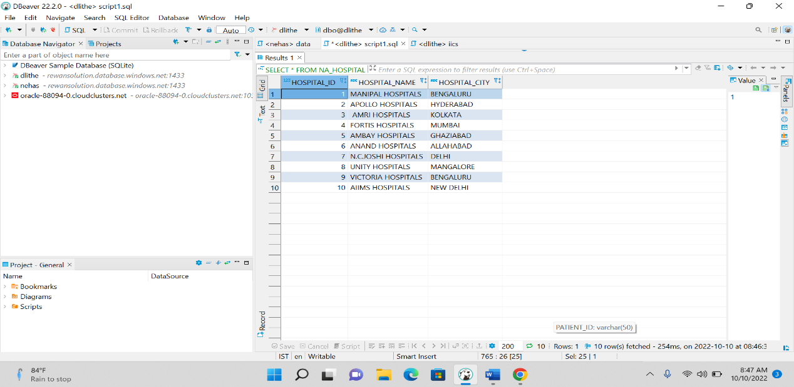

**CREATE** **TABLE** NA_DOCTOR(

DOCTOR_NAME **VARCHAR**(50),

DOCTOR_ID **VARCHAR**(50) **PRIMARY** **KEY**,

DOCTOR_SPECIALIST **VARCHAR**(50),

HOSPITAL_ID **INT** **FOREIGN** **KEY** **REFERENCES** NA_HOSPITAL(HOSPITAL_ID)

);

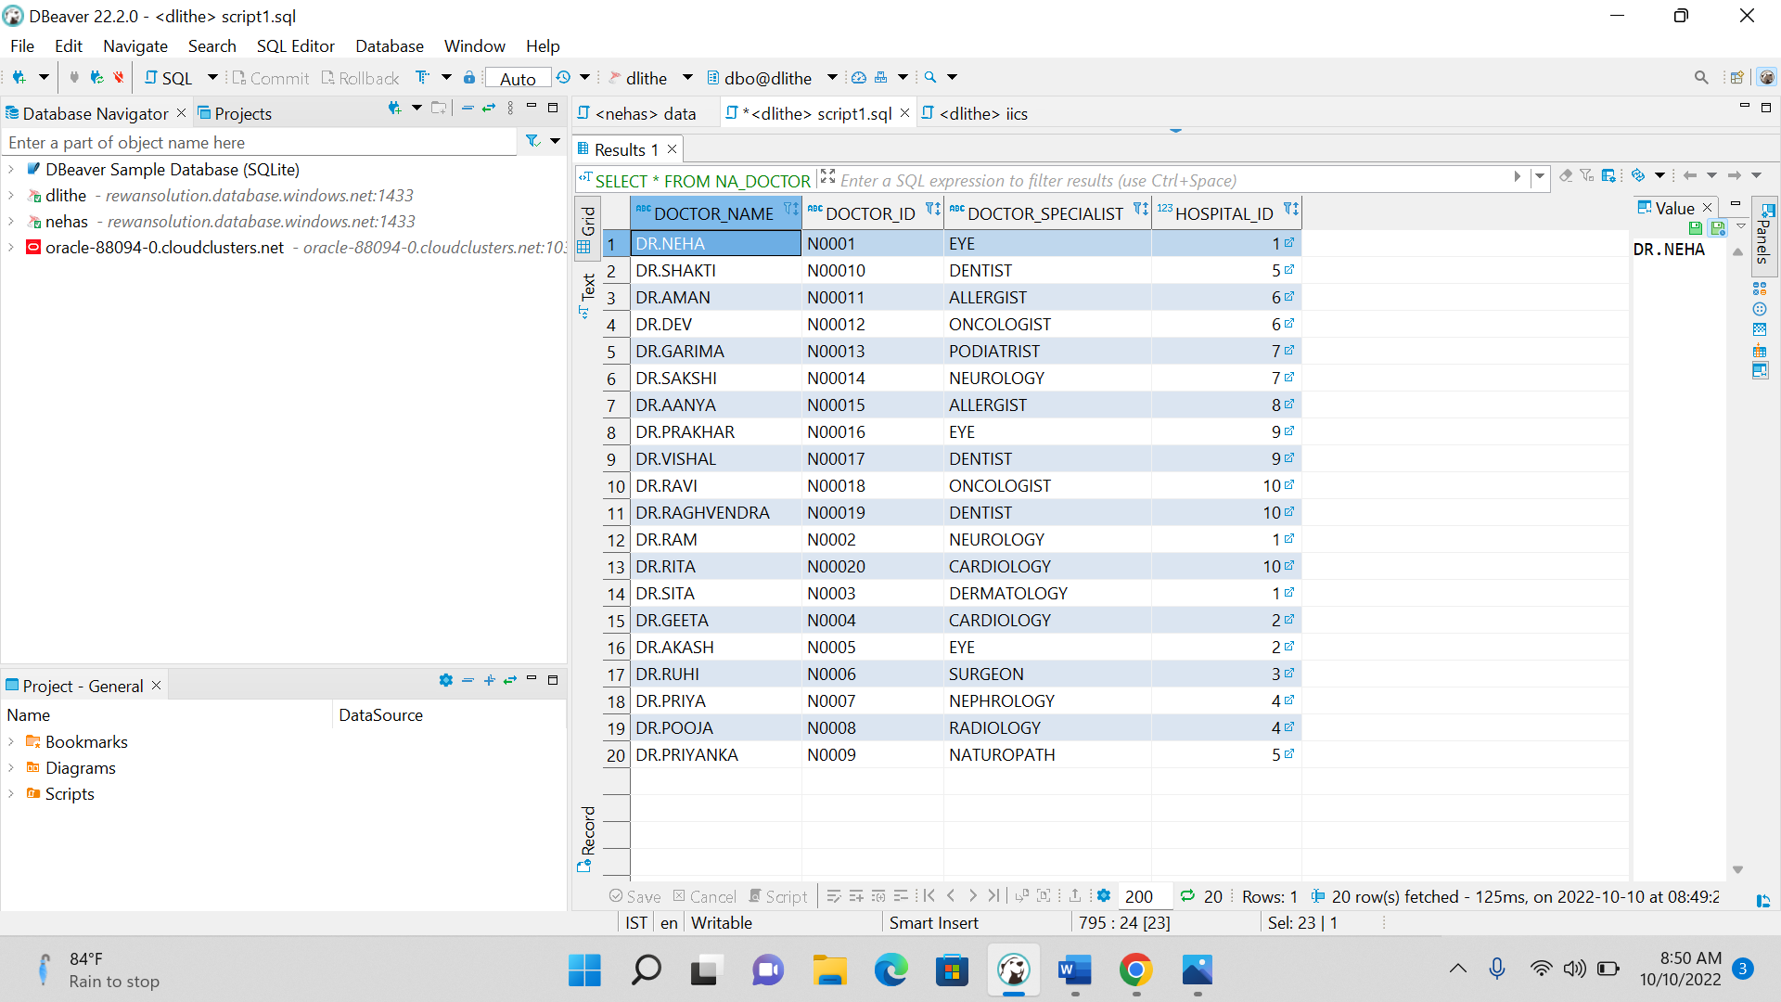

**CREATE** **TABLE** NA_PATIENT

(

PATIENT_ID **VARCHAR**(50) **PRIMARY** **KEY**,

PATIENT_NAME **VARCHAR**(50),

GENDER **VARCHAR**(50),

AGE **INT**,

CHECKUP_PROBLEM **VARCHAR**(50),

MEDICINE **VARCHAR**(50),

DOCTOR_ID **VARCHAR**(50) **FOREIGN** **KEY** **REFERENCES** NA_DOCTOR(DOCTOR_ID)

);

**INSERT** **INTO** NA_PATIENT **VALUES**('P01','AMY','FEMALE',18,'SKIN','CETIRIZINE','N0001')

**INSERT** **INTO** NA_PATIENT **VALUES**('P02','AVERYY','FEMALE',19,'HEART','MYOCARDIAL','N0002')

**INSERT** **INTO** NA_PATIENT **VALUES**('P03','AARNA','FEMALE',18,'PREGANCY','ACETAMINOPHEN','N0003')

**INSERT** **INTO** NA_PATIENT **VALUES**('P04','AARAVI','FEMALE',17,'BREATHING','ALBUTEROL','N0004')

**INSERT** **INTO** NA_PATIENT **VALUES**('P05','ANAYA','FEMALE',10,'SKIN','CETIRIZINE','N0005')

**INSERT** **INTO** NA_PATIENT **VALUES**('P06','ALICE','FEMALE',20,'KIDNEY','DAPAGLIFLOZIN','N0001')

**INSERT** **INTO** NA_PATIENT **VALUES**('P07','ABHISHEK',',MALE',28,'LIVER','ENTECAVIR','N0008')

**INSERT** **INTO** NA_PATIENT **VALUES**('P08','AMAN','MALE',30,'DIABETIES','RIOMET','N0007')

**INSERT** **INTO** NA_PATIENT **VALUES**('P09','ADARSH','MALE',50,'URINARY TRACT','FURADANTIN','N0002')

**INSERT** **INTO** NA_PATIENT **VALUES**('P10','AMBRISH','MALE',48,'LIVER','ENTECAVIR','N00010')

**INSERT** **INTO** NA_PATIENT **VALUES**('P11','BELA','FEMALE',18,'ALLERGY','LOSARTAN','N0001')

**INSERT** **INTO** NA_PATIENT **VALUES**('P12','BRYAN','MALE',18,'EYE','GABAPENTIN','N0001')

**INSERT** **INTO** NA_PATIENT **VALUES**('P13','BRYN','MALE',14,'ALLERGY','OMEPRAZOLE','N0003')

**INSERT** **INTO** NA_PATIENT **VALUES**('P14','BRANDO','MALE',78,'HEADACHE','PARACETAMOL','N0004')

**INSERT** **INTO** NA_PATIENT **VALUES**('P15','BHAVINI','FEMALE',38,'CHILDERN PROBLEM','METFORMIN','N0005')

**INSERT** **INTO** NA_PATIENT **VALUES**('P16','BRINDA','FEMALE',15,'THYROID','SYNTHROID','N0006')

**INSERT** **INTO** NA_PATIENT **VALUES**('P17','CAMILA','MALE',20,'KIDNEY','DAPAGLIFLOZIN','N0007')

**INSERT** **INTO** NA_PATIENT **VALUES**('P18','CARTER','MALE',48,'LIVER','ENTECAVIR','N0008')

**INSERT** **INTO** NA_PATIENT **VALUES**('P19','COY','MALE',66,'BONE','ANALGESICS','N0009')

**INSERT** **INTO** NA_PATIENT **VALUES**('P20','CHARVI','FEMALE',21,'MIND','LOSARTAN','N00010')

**INSERT** **INTO** NA_PATIENT **VALUES**('P21','CHLOE','FEMALE',22,'DIABETIES','RIOMET','N0001')

**INSERT** **INTO** NA_PATIENT **VALUES**('P22','CALI','FEMALE',30,'BREATHING','ALBUTEROL','N0008')

**INSERT** **INTO** NA_PATIENT **VALUES**('P23','DIKSHA','FEMALE',20,'HEART','ASPIRIN','N0003')

**INSERT** **INTO** NA_PATIENT **VALUES**('P24','DEEPTI','FEMALE',80,'EYE','ALBUTEROL','N0002')

**INSERT** **INTO** NA_PATIENT **VALUES**('P25','DIVYA','FEMALE',40,'HEADACHE','DOLO','N0006')

**INSERT** **INTO** NA_PATIENT **VALUES**('P26','DANIEL','MALE',31,'SKIN','CLARITIN','N0004')

**INSERT** **INTO** NA_PATIENT **VALUES**('P27','DAMAN','MALE',37,'HAIRFALL','ALBUTEROL','N0007')

**INSERT** **INTO** NA_PATIENT **VALUES**('P28','EMLI','FEMALE',37,'PRAGNACY','ACETAMINOPHEN','N0007')

**INSERT** **INTO** NA_PATIENT **VALUES**('P29','FIZA','FEMALE',27,'HAIRFALL','ALBUTEROL','N0006')

**INSERT** **INTO** NA_PATIENT **VALUES**('P30','GAGAN','MALE',25,'EYE','GABAPENTIN','N0007')

**INSERT** **INTO** NA_PATIENT **VALUES**('P31','HARSH','MALE',26,'KIDNEY','DAPAGLIFLOZIN','N0009')

**INSERT** **INTO** NA_PATIENT **VALUES**('P32','ISHAN','MALE',20,'EAR','BENZOCAINE','N00010')

**INSERT** **INTO** NA_PATIENT **VALUES**('P33','RAM','MALE',19,'TEETH','ADVIL','N00010')

**INSERT** **INTO** NA_PATIENT **VALUES**('P34','VISHNU','MALE',19,'DIABETIES','RIOMET','N0002')

**INSERT** **INTO** NA_PATIENT **VALUES**('P35','WARDAN','MALE',43,'LIVER','ENTECAVIR','N0006')

**INSERT** **INTO** NA_PATIENT **VALUES**('P36','REKHA','FEMALE',88,'KIDNEY','DAPAGLIFLOZIN','N0003')

**INSERT** **INTO** NA_PATIENT **VALUES**('P37','RAM','MALE',20,'HAIRFALL','ALBUTEROL','N0001')

**INSERT** **INTO** NA_PATIENT **VALUES**('P38','RIMA','FEMALE',29,'BONE','ANALGESICS','N0002')

**INSERT** **INTO** NA_PATIENT **VALUES**('P39','SUSHMA','FEMALE',19,'TEETH','ADVIL','N0007')

**INSERT** **INTO** NA_PATIENT **VALUES**('P40','SUNITA','FEMALE',16,'HEADACHE','PARACETAMOL','N0005')

**INSERT** **INTO** NA_PATIENT **VALUES**('P41','TINA','FEMALE',17,'EYE','GABAPENTIN','N0004')

**INSERT** **INTO** NA_PATIENT **VALUES**('P42','RAM','MALE',19,'KIDNEY','DAPAGLIFLOZIN','N0004')

**INSERT** **INTO** NA_PATIENT **VALUES**('P43','RAJA','MALE',11,'TEETH','DARAMOL','N0009')

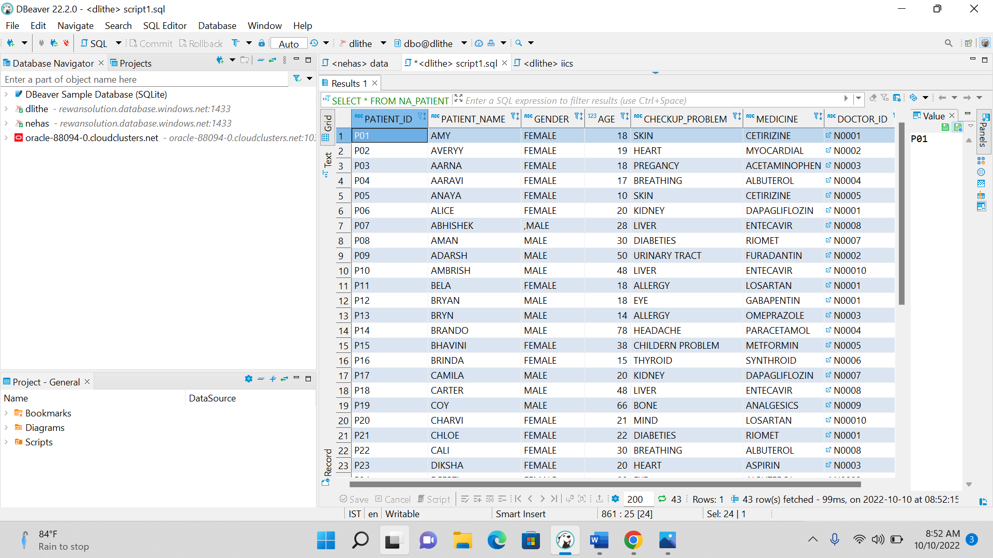

----VIEW FUNCTION----

**CREATE** **VIEW** NEW_NA_PATIENT

**AS** **SELECT** * **FROM** NA_PATIENT P

**SELECT** * **FROM** NEW_NA_PATIENT

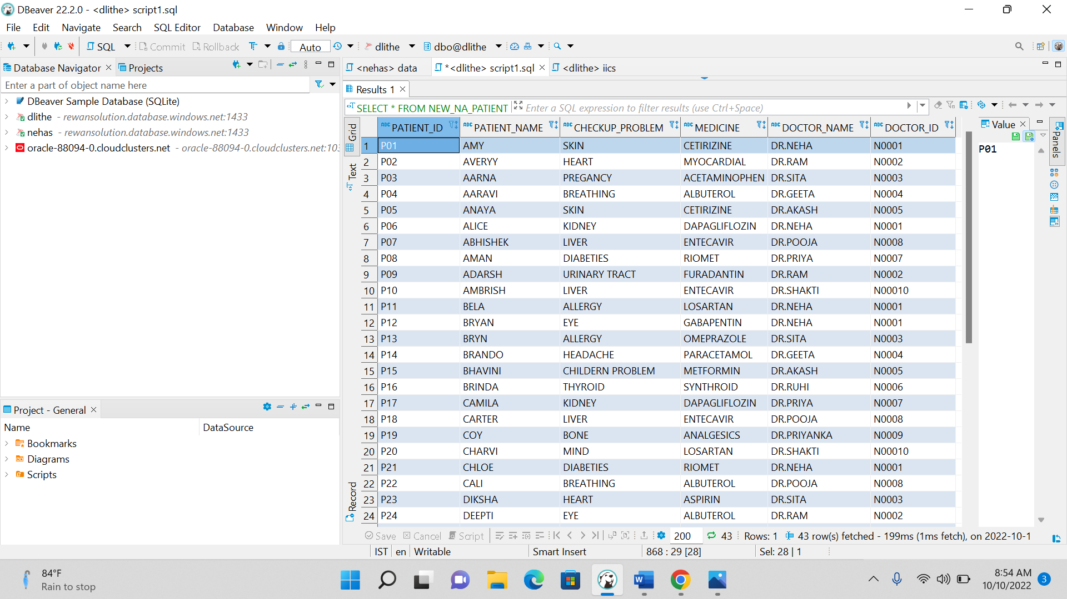

-------DDL,DQL COOMANDS ON SQL--

**ALTER** **VIEW** NEW_NA_PATIENT

**as** **select** P.PATIENT_ID,P.PATIENT_NAME,P.CHECKUP_PROBLEM,P.MEDICINE,

DOC.DOCTOR_NAME,DOC.DOCTOR_ID

**FROM** NA_PATIENT **AS** P

**INNER** **JOIN** NA_DOCTOR **AS** DOC

**ON**

P.DOCTOR_ID=DOC.DOCTOR_ID

**SELECT** * **FROM** NEW_NA_PATIENT

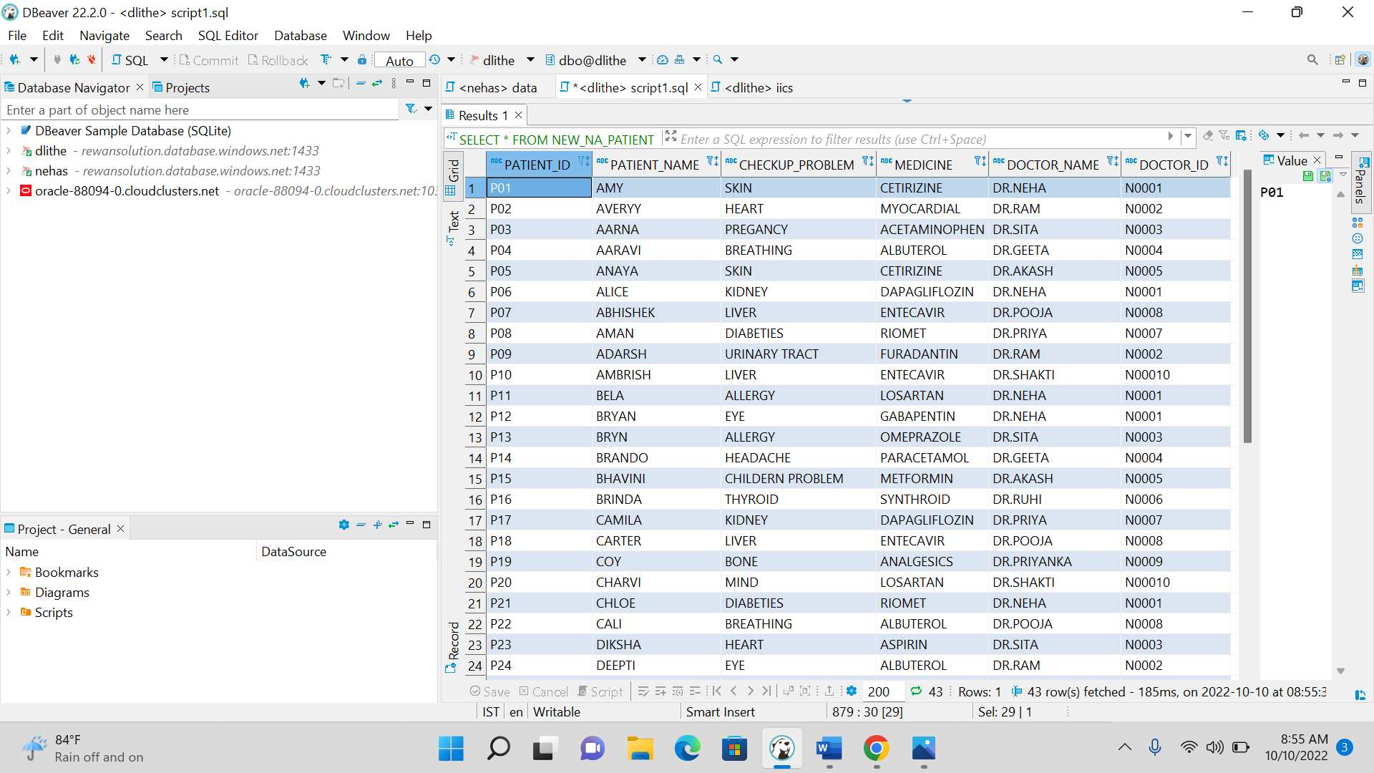

----JOIN FUNCTIONS---

**SELECT** P.PATIENT_ID,P.PATIENT_NAME,P.AGE,P.CHECKUP_PROBLEM,P.DOCTOR_ID,

DOC.DOCTOR_NAME,DOC.DOCTOR_ID

**FROM** NA_PATIENT **AS** P

**INNER** **JOIN** NA_DOCTOR **AS** DOC

**ON** P.DOCTOR_ID=DOC.DOCTOR_ID

**SELECT** P.PATIENT_ID,P.PATIENT_NAME,P.AGE,P.CHECKUP_PROBLEM,P.DOCTOR_ID,

DOC.DOCTOR_NAME,DOC.DOCTOR_ID

**FROM** NA_PATIENT **AS** P

**LEFT** **JOIN** NA_DOCTOR **AS** DOC

**ON** P.DOCTOR_ID=DOC.DOCTOR_ID

**SELECT** P.PATIENT_ID,P.PATIENT_NAME,P.AGE,P.CHECKUP_PROBLEM,P.DOCTOR_ID,

DOC.DOCTOR_NAME,DOC.DOCTOR_ID

**FROM** NA_PATIENT **AS** P

**RIGHT** **JOIN** NA_DOCTOR **AS** DOC

**ON** P.DOCTOR_ID=DOC.DOCTOR_ID

**SELECT** P.PATIENT_ID,P.PATIENT_NAME,P.AGE,P.CHECKUP_PROBLEM,P.DOCTOR_ID,

DOC.DOCTOR_NAME,DOC.DOCTOR_ID

**FROM** NA_PATIENT **AS** P,NA_DOCTOR **AS** DOC

----DDL ,DML---------

**select** * **from** NA_PATIENT

**where** PATIENT_NAME='AMY';

**select** * **from** NA_PATIENT

**where** PATIENT_NAME **like** '%A';

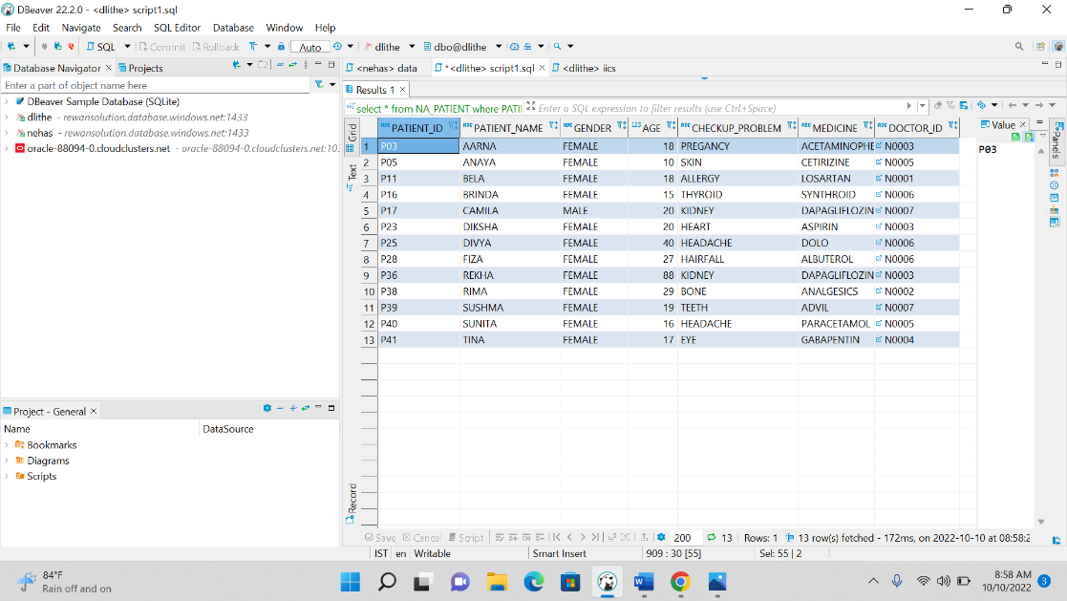

**select** * **from** NA_PATIENT

**where** PATIENT_NAME **like** 'A%';

**select** * **from** NA_PATIENT

**where** PATIENT_NAME **not** **like** 'A%';

**select** **Top** 3* **from** NA_PATIENT

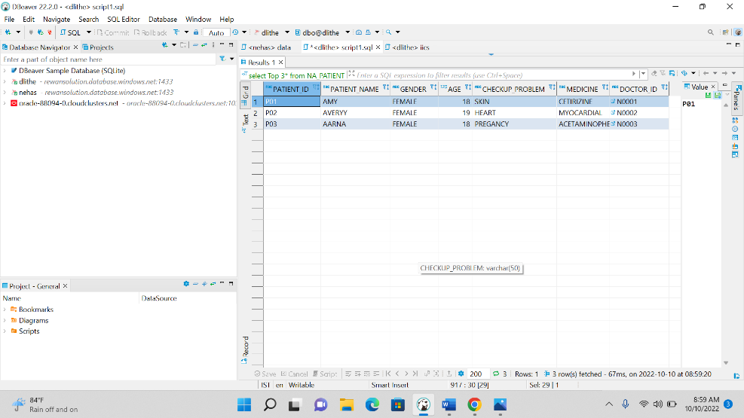

**select** **upper**(PATIENT_NAME) **as** fname,

**Lower**(PATIENT_NAME),**LTRIM**(**RTRIM**(PATIENT_NAME))

**FROM** NA_PATIENT

**select** **replace**('AVERYY','Y','@')

**FROM** NA_PATIENT

**select** **concat**(PATIENT_NAME,'+',PATIENT_ID )**as** PATIENT_NAME

**FROM** NA_PATIENT

**select**\* **FROM** NA_PATIENT **where** PATIENT_ID='P02'

**select** **count**(*) **from** NA_PATIENT

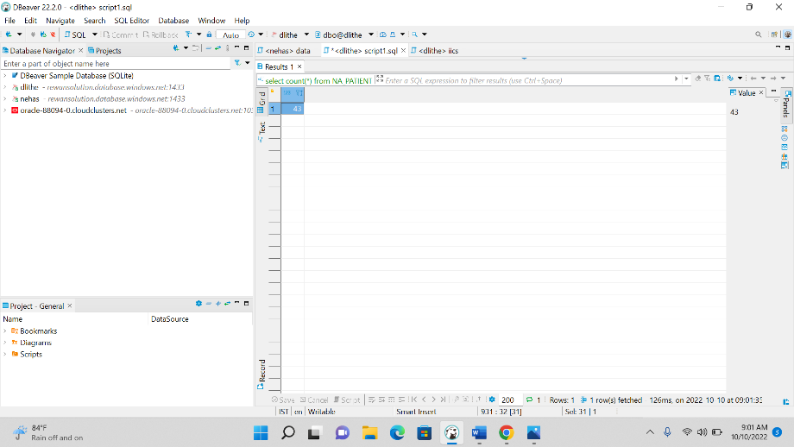

**select** **count**(1),HOSPITAL_ID

**FROM** NA_DOCTOR

**group** **by** HOSPITAL_ID

**having** **count**(1)>2

**order** **by** HOSPITAL_ID **ASC**

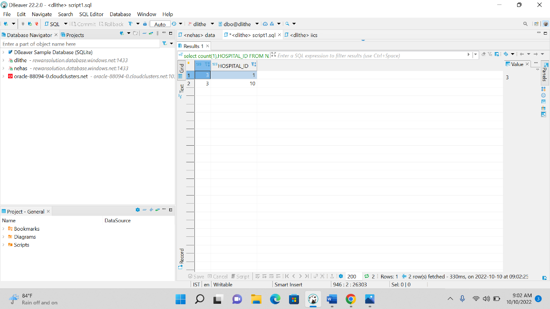

**select** PATIENT_NAME,PATIENT_ID,

**row_number**() **over** (**order** **by** PATIENT_ID) **as** rownumber

**FROM** NA_PATIENT

**select** PATIENT_NAME,PATIENT_ID,

**rank**() **over** (**order** **by** PATIENT_ID) **as** rankfn

**FROM** NA_PATIENT

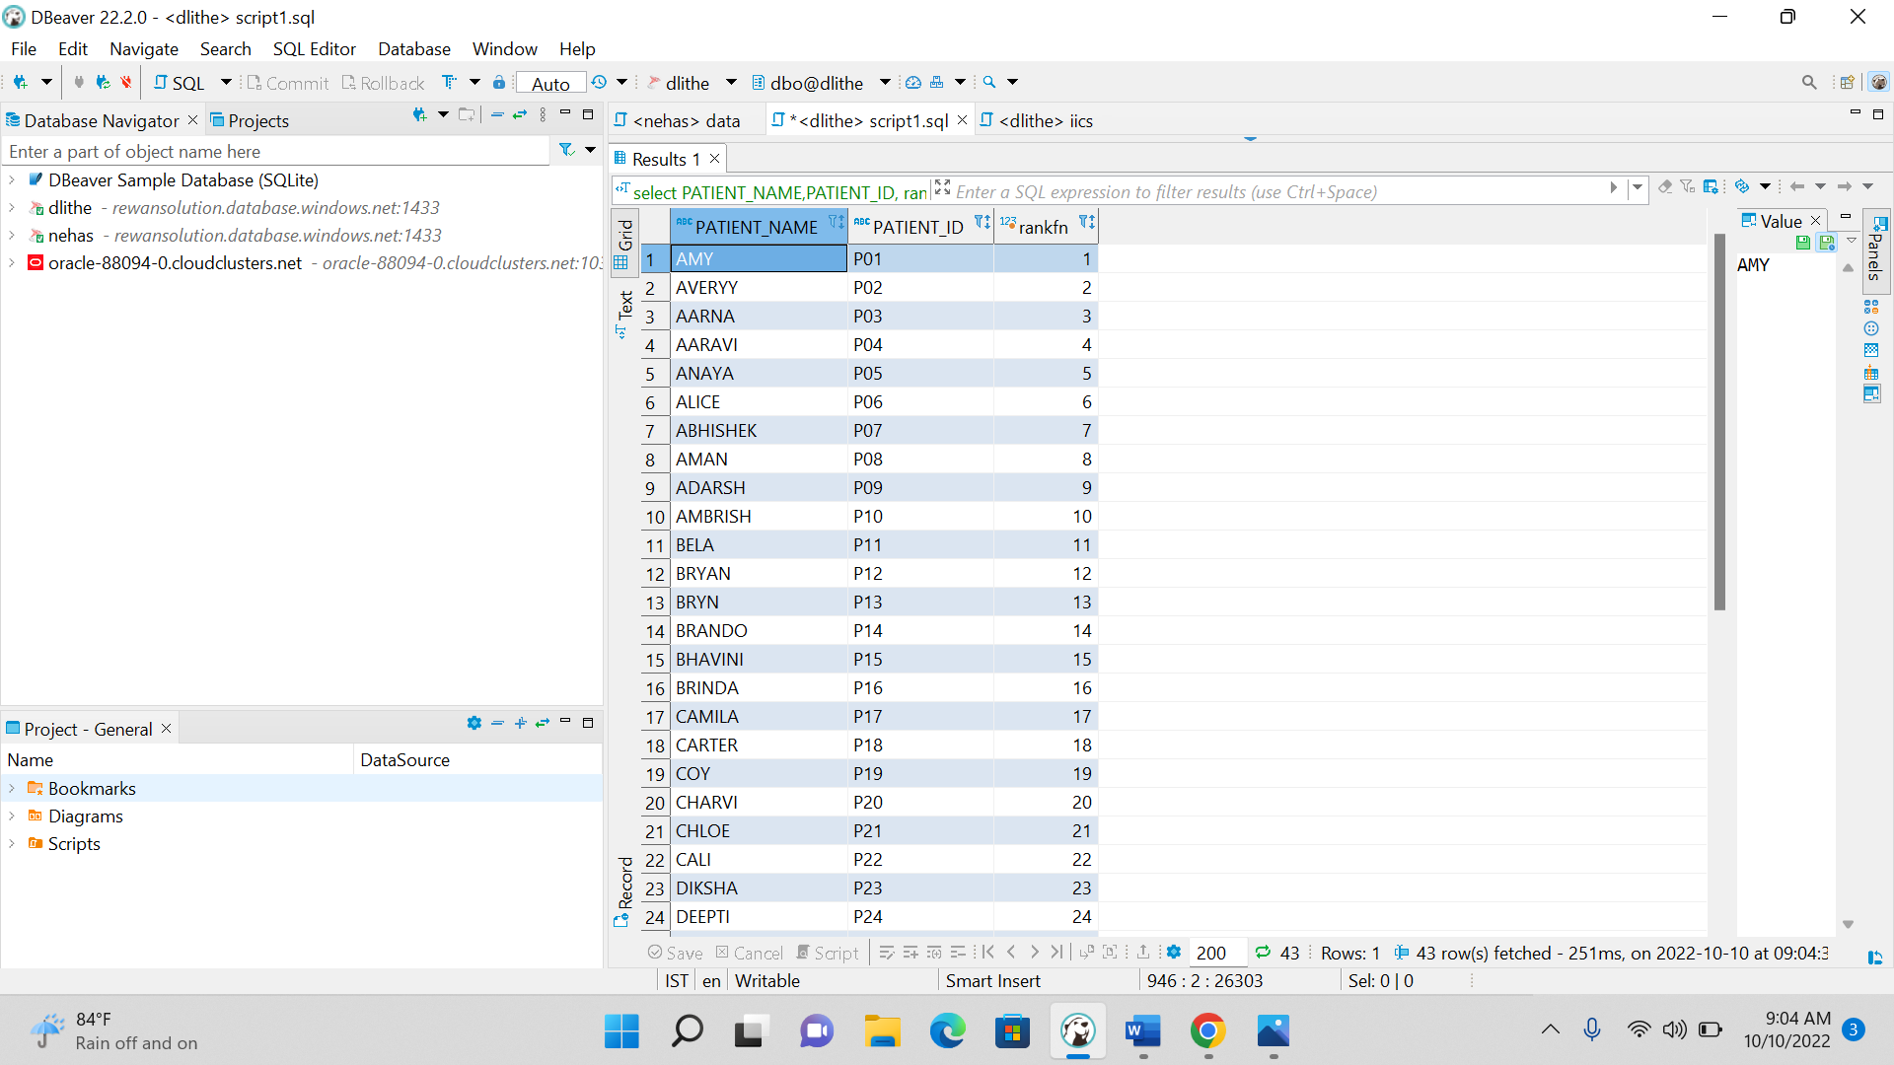

**select** PATIENT_NAME,PATIENT_ID,

**dense_rank**() **over** (**order** **by** PATIENT_ID) **as** denserankfn

**FROM** NA_PATIENT

--------------------------------

--delete ,drop,update functions---

**delete** **table** NA_PATIENT

**where** PATIENT_ID='P01'

**update** **table** NA_PATIENT

**set** **column** PATIENT_NAME='PAT_NAME'

**drop** **table** NA_PATIENT